OPTIMIZATION OF TEHNOLOGICAL PROCESS BY ANALYSIS OF EXISTING SITUATION OF PRODUCTION PROCESS

Elvin Okugić¹, Milan Jurković²
¹Univerzitet u Bihaću, Tehnički Fakultet Bihać, Ul. Dr. Irfana Ljubijankića bb, 77 000 Bihać, Bosna i Hercegovina
email: elvin.okugic@gmail.com¹
¹Univerzitet u Bihaću, Tehnički Fakultet Bihać, Ul. Dr. Irfana Ljubijankića bb, 77 000 Bihać, Bosna i Hercegovina
email: mi.jurkovic@gmail.com²

ABSTRACT:

The main goal of the research in this paper is the analysis and optimization of the technological process of production in the company SANI GLOBAL with the aim of finding measures for improving and enhancing the process. These measures should enable the improvement and optimization of the technological process of production, and the result will be a reduction in production costs, increased labor productivity and utilization of production capacity and raw materials. The paper explains the analysis of the existing state of the production process, which is applied in a way to analyse the existing state of the production process, to identify problems in the production process and bottlenecks and finally to apply the optimization procedure by analyzing the existing state.

Keywords: optimization, process, tehnology, wood procesing, analysis

1. INTRODUCTION

In engineering, optimizing means finding the maximum or minimum of given goal or goals within a certain limit. Restrictions can be as different as they are available resources, quality level, inability to invest, etc. Optimization is not tied only with engineering, so it can be said that people also in everyday life constantly optimize, although they are not always aware of it. Finding the right way of allocating and plan for spending income is a good example of daily optimization. Sequence of performing jobs is usually determined on the basis of some criteria (minimum time, minimum costs, etc.). Unlike general optimization, the engineering optimization process requires systematic search for the optimal solution of the engineering problem, in accordance with the objective function and within the permissible range of solutions that determine the various constraints. With the mentioned optimization method, there are a number of different methods of process improvement that can successfully optimize the production process. Some of them are: Six sigma, Reengineering of business processes, Lean management, Kaizen, Benchmarking, Process of Business reengineering, etc. The optimization of the technological process affects the work of the company and contributes to the company in a way that the company has numerous benefits from optimization. Process optimization increases business productivity, which is very important because of competition. This paper presents ways to increase the productivity of the company by optimizing the production process, taking into account all the issues in the analysis of the current state of the production process. Regardless of the size of the company, effective company management is extremely important. With effective management, all operations and processes are performed without downtime and this should be the daily activity of every company. Production optimization is the constant introduction of new methods of work that improve the production process. Increased market demands and the need for quality products create the need to optimize the production process while consuming the optimal amount of raw materials and applying available resources. [2]

2. COMPETITIVE ADVANTAGE AND REDUCTION OF OPTIMIZATION COSTS OF TECHNOLOGICAL PROCESS

The process of manufacturing wood products is a continuous process that is determined by a high level production, high costs, continuity of production and high energy costs. Costs of energy are extremely high, and can reach up to 60 % of total production costs. Because the most optimization methods have goal to reduce production costs, it is evident that optimization processes in the wood industry will seek to reduce production costs and thus total production costs. By reducing production costs in the company, competitive advantage grows. A very important activity in the process of cost reduction is identifying the places where unjustified spending or energy loss occur. Although technology itself very often determines energy loss, it is important to try to use at least part of that energy, and thus raise the efficiency of production process. Elimination of losses should not be limited only to energy, but it should be applied to all existing resources. In the wood industry and in wood products and wood materials in general, the method of analysis of the existing condition can be applied because that method continuously improves the processes, based on the measurement of key parameters and detailed analysis. By the method of analysis of the existing condition, the desired quality is achieved, it also reduces variability of process and aims to meet customer requirements and desires and reduces losses of energy. The main recommendations for reducing costs in Sani Global company are optimal electricity consumption, especially for machines that consume the most electricity, such as a horizontal band saw in primary wood processing. It is recommended that the primary wood processing is performed during the lower electricity price and the installation of frequency converters on bigger electric motors. This could reduce electricity consumption by 6 %, ie the total production costs would be lower. An important measure to reduce costs is maximum use the most of logs. Sawing logs produces the sawdust waste. The largest amount of sawmill waste is produced during the sawing of logs in sawmills, ie when sawing with a band saw. This does not refer to sawdust as sawdust residue but to the edges of the log. This approach does not use the entire log and unnecessarily neglects the part of the log that becomes sawmill waste. It is also recommended to reduce the time for operations that lasts long. In this case, the operation of drying wood boards, which lasts 30 days, was chosen. In this case, laboratory tests are very useful. It is recommended that wood boards samples from the company be sent to a laboratory testing in order to test whether the drying can take less time but without losing the physical and mechanical characteristics of the wood. By reducing the drying time, the total production time is also reduced. Further recommendations for the optimization of the technological process are the introduction of CNC machines and quality control. In order to better organize the production, it is recommended to introduce the Kaizen and Just in time method. Both methods recommend involving all employees in the work, proposing optimization solutions, shortening the transition time from one operation to another, etc., which can significantly reduce costs and increase the competitive advantages of the company. [1][2]

3. ANALYSIS OF CURRENT STATE OF PRODUCTION IN “SANI GLOBAL” d.o.o. Bihać

The production process in the company “Sani Global” d.o.o. Bihać is divided into several separate production sections, so the processes are analyzed separately, and they are as follows:
- production of massive panels,
- production of beech plywood,
- production of wood elements and panels for workbenches.

This paper refers to the production of massive panels.

3.1. Production of massive panels
Production of massive panels in the company “Sani Global” d.o.o. Bihać takes place in production plant, and the production plant consists of the following phases: 1. Log yard, 2. Primary sawmill, 3. Secondary sawmill, 4. Administration building, 5. Space for sorting and stacking sawn timber, 6. Wood steaming chamber, 7. Drying kiln and 8. Auxiliary hall that serves as a storage room and for tool sharpening.

Figure 1. shows a massive panel that is produced in the production plant of company
Sani Global d.o.o. Bihać, which contains the following characteristics (Table 1.).

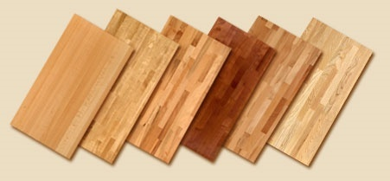
Figure 1. Massive panel [1]

Big products | Length and width joined panels | Width-joined panels
Type of wood | Beech, Oak | Beech, Oak
Thickness | 18, 20, 25, 40, 45 mm | 20, 25, 40, 45 mm
Length | Up to 5000 mm | Up to 3000 mm
Width | Up to 1250 mm | Up to 700 mm
Width of lamellae | 20 to 42 mm | 40 to 72 mm
Quality | A/B, B/B and Kern | A/B and Kern
Humidity | 8 % ± 2 % | 8 % ± 2 %
Gluing | DIN EN 204 / D3 or D4 | DIN EN 204 / D3 or D4
Finishing | On request | On request
Table 1. Characteristics of massive panels
All these phases need to be carefully performed in order to obtain a quality massive panel that meets the requirements and wishes of customers.The analysis of the phase of the technological process of the company that was carried out identified several functional problems. Numerous irregularities were identified due to poor organization of the production process. The biggest problem was discovered in the primary sawmill, ie in the primary processing of wood when sawing logs into boards. Primary processing is performed on one horizontal band saw. This phase is not performed according to standard procedures which causes problems. Wood boards are often not subjected to quality control because the logs have natural defects (defects in structure, defects in color and consistency of wood and defects from insects). Boards with such wood defects unnecessarily increases the company's costs and are often the reason for delayed delivery to customers. In addition, the company does not control the quality of materials or raw materials from which solid boards are made. Materials (logs) without previously performed quality controls are forwarded to the primary processing of wood where the logs are sawn into the boards. After the log is sawed into boards, boards are sorted and stacked, and than dried in a dryer, followed by secondary wood processing. In primary wood processing, there is another problem that interferes regular functioning of the technological process. This problem is frequent downtime of band saw which cause disturbances in the whole technological process, and the waiting for the repair of machines is relatively long. It was also noted that the company has no spare parts so that machinery and equipment can be repaired quickly after a breakdown. In addition, there are no instructions for use for all machines and equipment located in the company. Machine downtime slows down production, time is wasted, and one of the goals of optimization is production in the shortest possible time. Another problem with a band saw is that the sawdust is not completely sucked out. By sawing the logs, the sawdust goes through the suction hose for further processing, but not all sawdust. A significant amount of sawdust still remains on the band saw. One of the problems in the company is the drying of the boards. Drying is an important phase of the technological process, and the biggest problem is that drying takes too long. Due to this, the production will last longer. The company did not test the quality of glued joint in tension for finger jointing of elements, and also company did not test the quality of the glued joint for edge jointing. These two glued joints are extremely important for achieving the quality of the final product. Achieving product quality is one of the goals of optimization. In the analysis of the existing state of the process, it was noticed that the elements are often of badly glued during finger jointing. When the lamellaes come out of the press, there is often a break on it because the two elements are not glued well. [1]

4. OPTIMIZATION OF THE TECHNOLOGICAL PRODUCTION PROCESS OF MASSIVE WOOD PANELS

Today, at the beginning of the 21st century, but also 30 years ago, technologies and processes can be the same by the procedure of performing, and yet between them there may be great differences which are the result implementation of knowledge, innovation and optimization methods when technological processes take higher techno-economic level and significantly higher profitability. In the past it was important to produce, but today, survival is possible by constantly improving processes and technologies, all with the goal to achieve a competitive advantage in the market. It is produced so that it can be sold, and it can be sold if the optimal techno-economic results in all segments of the work cycle are achieved. Otherwise, a successful result on the market is questionable, and with it, the real survival of producers. Modern production systems have their own polygon of proof in the market, there are wins or loses. And, that's why production is a dynamic process that needs to be nurtured, upgraded, improved, in which there must be no stagnation, because stagnation is a setback and loss of the market, and then the disappearance of the production-business system.

4.1. Goals of optimization

The full definition of optimization is determined by four basic elements (Figure 2), the object of optimization, the goal of optimization, the methods of optimization and by the conditions in which optimization performs.

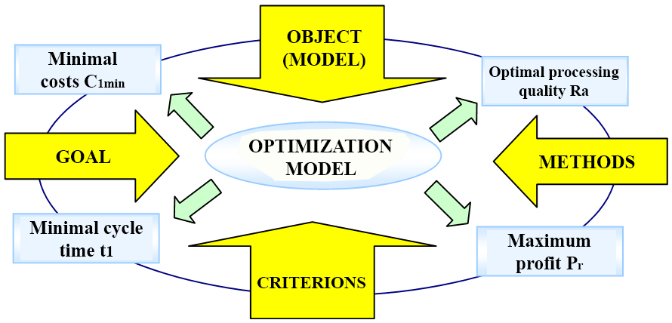

Figure 2. Basic elements and requirements of the optimization process [6]

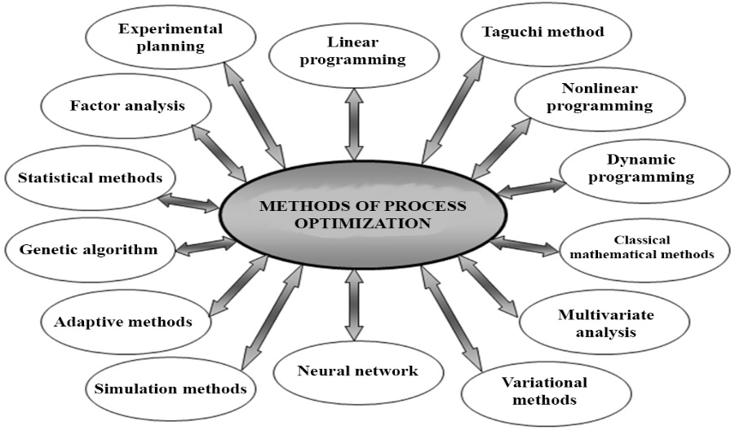

Figure 3. Methods of process optimization [5]

The goal of optimization is expressed using optimization criteria (optimization model and goal function), while with the appropriate optimization method it is achieved the desired optimization goal on specific optimization object (process, processing system, product, device, technology, design, management, etc.).
4.2. Optimization by analysis of the existing situation
The analysis of the existing situation determines the real state of macro and micro processes whose goals are shown in Figure 2. and the bases for the performance of optimization can be achieved by applying: detailed macro and micro analysis of the current state of production, modelling of processes and systems as pre-optimization phases, implementation of innovations and incorporation of knowledge and implementation of new technologies and processing systems in production processes. Analysis of the existing situation is a source of information about the real state of production, which must be concrete with measurable goals and a higher levels, and not a formal understanding of the situation. The analysis should be performed in several directions: 1. Technology analysis; 2. Process analysis; 3. Comprehensive analysis of cycles and cycle times; 4. Analysis of equipment, capacity utilization, technological level; 5. Product quality analysis; 6. Cost analysis for each product and total cost analysis; 7. Management analysis. Therefore, optimization must be based on a complex analysis of the effectiveness of the existing technological process and / or production process and all their components. In order to improve the technology and economy in the company, it is necessary to improve existing processes, technologies and machining systems by applying the methods of optimization, cost minimization and shortening of manufacturing cycle, application and introduction of modern CNC technologies and systems in the process and expanding the existing production facilities in accordance with market requirements and criteria of techno-economic efficiency, and implementation of modern quality systems in production and business processes. [5]

5. CONCLUSION
Objective was to prepare a development strategy for the production - business system “Sani Global” d.o.o. Bihać for the next 10 years with the aim of introducing modern technologies and processing systems and achieving a higher technological level, quality and quantity of products that will have greater competitiveness in the market.
Also, the construction of a new production hall creates production conditions for well-known foreign customers who are satisfied with the quality of the product, but this is not a constant, so the quality should be constantly improved.
It should be emphasized that modern CNC technologies and processing systems should be introduced, that provide higher product quality and better techno-economic efficiency.

6. REFERENCES

[1] Elvin Okugić.: (2020), Analiza i optimizacija tehnološkog procesa u proizvodnom pogonu Sani Global s prijedlogom mjera za unaprijeđenje procesa, Magistarski rad, Tehnički Fakultet Univerziteta u Bihaću

[2] Elvin Okugić, Milan Jurković.: Analiza tehnološkog procesa u proizvodnom pogonu Sani Global [DEMI 2017, Univerzitet u Banjaluci, Bosna i Hercegovina]

[3] Grladinović T. Upravljanje proizvodnim sustavima u preradi drva i proizvodnji namještaja. Zagreb: Šumarski fakultet; 1999.[2] Jurković M. Matematičko modeliranje inženjerskih procesa i sistema. Bihać: Mašinski fakultet; 1999.

[4] Jurković M. Reinženjering proizvodnje: Razvoj i modernizacija proizvodnje. Bihać: Tehnički fakultet; 2007.

[5] Jurković M. Reinženjering proizvodnih poduzeća: Razvoj i modernizacija proizvodnje. Bihać: Univerzitet u Bihaću; 2011.

[6] Jurković M, Tufekčić Dž. Tehnološki procesi: projektiranje i modeliranje. Tuzla: JU Univerzitet u Tuzli; 2000.
[7] Grupa autora – Inženjerski priručnik IP4, Proizvodno strojarstvo, Treći svezak,
Organizacija proizvodnje, I izdanje, Školska knjiga, Zagreb, 2002.

